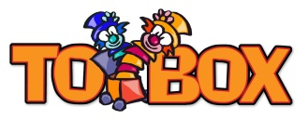

How to make you own

Feelings resource
Materials needed
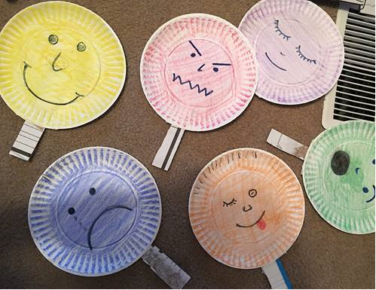
- Paper plates / Cardboard / Cereal box (to give structure)
- Cup / Circle shape
- Scissors
- Blank paper
- Glue
- Markers / pens / paint

- If you have paper plates draw individual emotions / feelings on to each plate e.g. happy, sad, excited, scared (See photo of emotions discs for ideas).
- If you don’t have paper plates, cut out circles in the cardboard using a cup or any circle shape.
- Use your carboard circle and draw around it on the blank paper, cut them out, then stick them on and leave to dry.
- When the circles are dry, draw on as many individual feelings / emotions.
- Encourage children to suggest emotions / feelings and what they will look like.
- Encourage children to share experiences of times when they felt happy, sad, scared etc…
Additional activities
- Have a mirror available for children to look at their faces when expressing the different emotions.
- Take photographs of your child expressing the emotions, these could be printed and added to make very personal emotions / feelings discs.
- Reassure children it is ok to feel all emotions and give tools on how to express them.
- Encourage all children to talk and give them ideas on all the people within the family / community to talk to for example –
Family – Mum, Dad, Sister, Brother, Granny, Grandad, Aunt, Uncle
Community – School – teacher/ classroom assistant, Tutor, Coach etc
A trusted person
- A good film that explains emotions / feelings and how they all have a place.

