
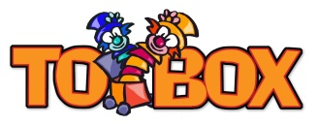

Suggested story books to read

The Hug - Eoin Mc Laughlin
Guess How Much I Love You - Ruth Krauss
While We Can’t Hug - Eoin Mclaughlin
The Worrysaurus - Rachel Bright
My Monster and Me - Nadiya Hussain
Peace at Last - Jill Murphy
The Gruffalo - Julia Donaldson
The Gruffalo’s Child - Julia Donaldson
Daisy Dinosaur Gets Lost - Steve Smallman
The Selfish Crocodile - Faustin Charles
The Lonely Giraffe - Peter Blight T
One Winters Day - M. Christina Butler
Room on The Broom - Julia Donaldson

Stories on line to view
Please see links below:

• Owl Babies: https://www.booktrust.org.uk/books-and-reading/have-some-fun/storybooks-and-games/owl-babies/

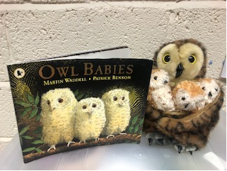

• We’re Going on a Bear Hunt: https://www.youtube.com/watch?v=0gyI6ykDwds

(the author is videoed with the pictures, expressing sounds and facial expressions)

• The Gruffalo: https://www.bbc.co.uk/iplayer/episode/b00pk64x/the-gruffalo

(This is an animation of the story on BBC Iplayer (you do have to click that you have a TV licence to watch this).

Suggested comments parents could use to explore feelings with their child.

It sounds like you are (angry, upset, happy) Is that right?
“You look sad this morning”
“What a big smile! I think you look happy today”
“You sound excited about going to the ----”
“I can see by your face that you are--------"
“You are laughing it looks like you are …………….”
“Oh no, you had built all the blocks up high and they fell down. How frustrating”
“You are sad because ------ has to go home
“You are feeling sad. You miss your……….”
“You’re excited you see lots of toys to play with”
“I see that you are angry”
“What is making you sad”

