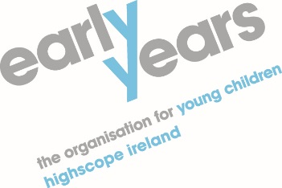
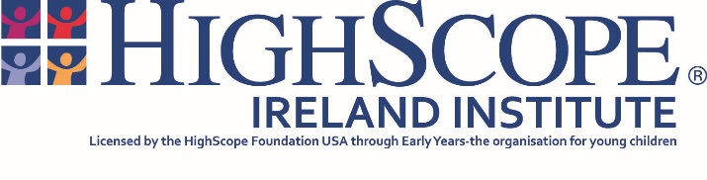

HighScope Preschool Curriculum Course
(For practitioners working with children aged 3 – 6 years)
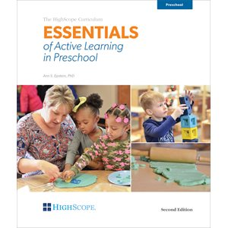

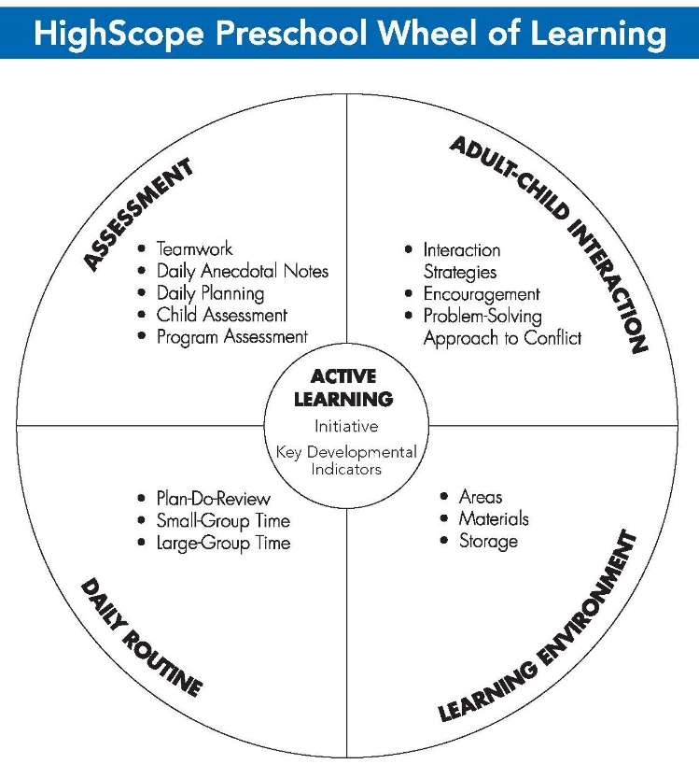

What is HighScope?

HighScope is a well-established approach to early childhood education and care which is underpinned by developmental and learning theory and by long term research. It is an approach which identifies and builds on children’s interests and abilities and is used internationally in a variety of settings.

Who is the course for?

The course is designed for those working with young children from 3-6 years of age who wish to begin to use the HighScope approach in their setting.

What does the course cover?

The course provides participants with the opportunity to explore the areas of the HighScope Curriculum for preschool children as outlined in the above HighScope Preschool Wheel of Learning.

The course offers participants the opportunity to discuss and reflect on the theory, principles and practice which underpin the HighScope Curriculum.

The course provides participants with an active learning experience and a mixture of individual small group, large group activities and discussions.

The course consists of 12 full days training delivered over a 12-month period to enable participants to gradually introduce the Curriculum in their setting, with assignments set at the end of each day. At the end of the course, the trainer will carry out a site visit to each setting. On successful completion of all of these course requirements participants will receive a HighScope Ireland Certificate of Implementation.
COURSE COST
6 online sessions and 6 face to face sessions
1 per month

DETAIL | COST (£)
Twelve days training  Includes site visit, registration fee | £1,250+VAT
Resources  £77.20 x 1 (member)  £85.75 (non-member) | £77.20 or  £85.75
Travel  XX @ 45p per mile x 6 days x 2 tutors - Training  XX @ 45p per mile x No. of End of Course Activities | TBC
Pre-School PQA Booklets for End of course Activity  (1 per Activity) x £13.00 | £13.00 per Activity  (TBC)

Resources necessary for Course

Publication | Member Price | Non-Member Price
Essentials of Active Learning | £21.40 | £23.75
Pre-School Programme Quality Assessment PQA Form A | £11.70 | £13.00
Pre-School COR Advantage 1.5 Scoring Guide | £15.30 | £17.00
Pre-School COR Advantage 1.5 Anecdotes Book* | £1.80 | £2.00
Pre-School COR Advantage 1.5 Desk Reference | £9.00 | £10.00
Pre-School COR Advantage 1.5 Training Booklet | £9.00 | £10.00
Pre-School Curriculum Participant Guide | £9.00 | £10.00
TOTAL (per participant) | £77.20 | £85.75

Please note
All Groups where applicable, will be charged the Euro bank rate on the day payment is processed through the bank.
All resources and training must be paid in advance of course commencement.

Thank-you

