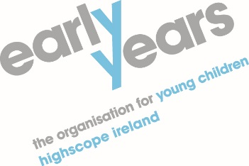
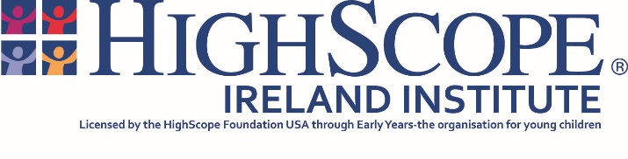

HighScope Infant and Toddler Curriculum Course (for practitioners working with children from birth to 3 yrs)
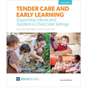

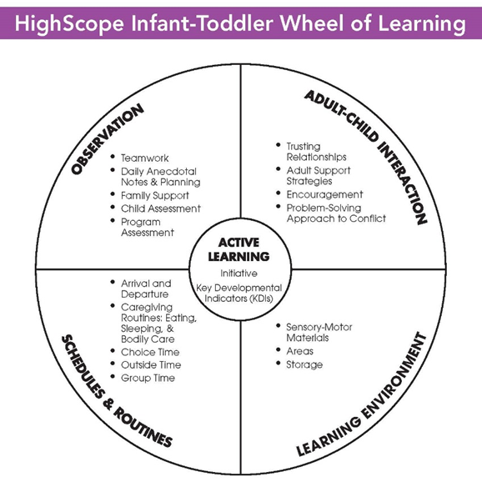

What is HighScope?

HighScope is a well-established approach to early childhood education and care which is underpinned by developmental and learning theory and by long term research. It is an approach which identifies and builds on children’s interests and abilities and is used internationally in a variety of settings.

What does the course cover?

The course provides participants with the opportunity to explore the areas of the HighScope Curriculum for infants and toddlers as outlined in the above HighScope Infant and Toddler Wheel of Learning.

The course offers participants the opportunity to discuss and reflect on the theory, principles and practice which underpin the HighScope Curriculum.

The course provides participants with an active learning experience and a mixture of individual small group, large group activities and discussions.

The course consists of 12 full days training delivered over a 12-month period to enable participants to gradually introduce the Curriculum in their setting, with assignments set at the end of each day. At the end of the course, the trainer will carry out a site visit to each setting.

On successful completion of all these course requirements participants will receive a HighScope Ireland Certificate of Implementation.

COURSE COST – 6 face to face & 6 online sessions .
DETAIL | COST (£)
Online Delivery of twelve-day course up to 16 attending –  Two tutors for twelve days (6 on-site, 6 online ) | £6084.00+ VAT
Course Registration Fee (£45 per participant) | £45+VAT x No. Participants
End of Course Activity (£507 per participant)  End of course Activity can cover up to 2 participants if they work in the same room | £507.00+ VAT  To be confirmed (TBC)
Travel  XX @ 45p per mile x 6 days x 2 tutors - Training  XX @ 45p per mile x No of End of course activities | TBC
Infant and toddler PQA Booklets for End of course Activity  (1 per Activity) x £17.00 | £17.00 per Activity  (TBC)
Course Resources x £134.35 (per participant – members)  Course Resources x £148.50 (per participant – non-members) | £134.35 x No. participants  Or  £148.50 x No. participants
(NB: Cost of Venue and Refreshments are not included in the Cost of Training as set out above)

Resources necessary for Course

Publication | Member Price | Non-Members Price
Infant & toddler Programme Quality Assessment PQA Form A | £15.30 | £17.00
COR Advantage Scoring Guide | £15.30 | £17.00
COR Advantage 1.5 Anecdote Book | £1.80 | £2.00
COR Advantage Desk Reference | £9.00 | £10.00
TCEL | £29.25 | £32.50
HighScope Curriculum for Infant and Toddlers  Training Series - COR Advantage | £9.00 | £10.00
HighScope Curriculum for Infant and Toddlers  Training Series - PQA Infant and Toddler | £9.00 | £10.00
HighScope Curriculum for Infant and Toddlers  Training Series - Learning Environments | £9.00 | £10.00
HighScope Curriculum for Infant and Toddlers  Training Series - Daily Schedules and Caregiving routines | £9.00 | £10.00
HighScope Curriculum for Infant and Toddlers  Training Series - Adult-Child Interactions | £9.00 | £10.00
HighScope Curriculum for Infant and Toddlers  Training Series - Active Learning | £9.00 | £10.00
HighScope Curriculum for Infant and Toddlers  Training Series - Working in Teams with Parents and Caregivers | £9.00 | £10.00
TOTAL (per participant) | £134.35 | £148.50

Please note
All Groups where applicable, will be charged the Euro bank rate on the day payment is processed through the bank.
All resources and training must be paid in advance of course commencement.

Thank-you

